# Trip@Us - Your Friendly Travel Planner

Hello park, please find your curated itineary for your Singapore visit below :).   
   
 We provide a detailed day by day breakdown of your trip to some of the places we know you will love. And what's more, our core algorithm optimised your travelling distance so that you can spend more time at the places you love :)

# Day 1

* City Square Mall
* Cable Car to Sentosa Island: Leisure & Attractions & Beaches
* ION Orchard Mall
* 313@Somerset Mall
* Bugis Junction Mall

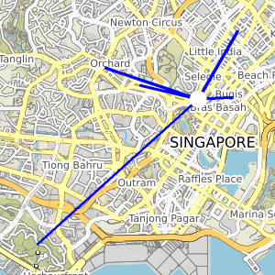

# Day 2

* Jurong Bird Park Singapore: Attractions & Things to Do
* Mustafa Centre
* Marina Barrage
* Merlion Park Singapore: Attractions & Things to Do
* Marina Square Mall

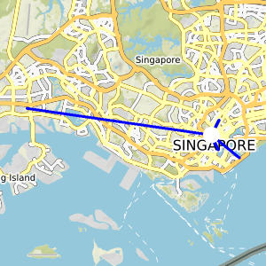

# Day 3

* Pulau Ubin & Singapore Islands
* S.E.A. Aquarium
* Ngee Ann City
* Orchard Central
* Plaza Singapura

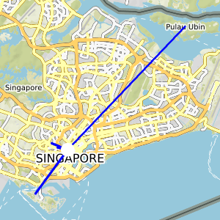

# Day 4

* Singapore Flyer in Sentosa Island
* Singapore River: History & Culture Tours

